Java Lab Programs

1. Develop a Java program that prints all real solutions to the quadratic equation ax2+bx+c = 0. Read in a, b, c and use the quadratic formula. If the discriminate b2 -4ac is negative, display a message stating that there are no real solutions.

Program:
import java.util.Scanner;

class Quadratic {
public static void main(String args[]) {

double a, b, c;
double discriminant, root1, root2;

Scanner sc = new Scanner(System.in);

System.out.print("Enter value of a: ");
a = sc.nextDouble();

System.out.print("Enter value of b: ");
b = sc.nextDouble();

System.out.print("Enter value of c: ");
c = sc.nextDouble();

discriminant = b * b - 4 * a * c;

if (discriminant < 0) {
System.out.println("There are no real solutions.");
}
else if (discriminant == 0) {
root1 = -b / (2 * a);
System.out.println("One real solution:");
System.out.println("x = " + root1);
}
else {
root1 = (-b + Math.sqrt(discriminant)) / (2 * a);
root2 = (-b - Math.sqrt(discriminant)) / (2 * a);

System.out.println("Two real solutions:");
System.out.println("x1 = " + root1);
System.out.println("x2 = " + root2);
}

sc.close();
}
}

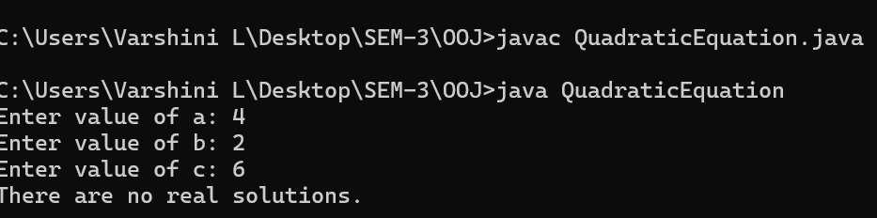

2. Develop a Java program to create a class Student with members usn, name, an array credits and an array marks. Include methods to accept and display details and a method to calculate SGPA of a student.

import java.util.Scanner;

class Student {
String usn;
String name;
int[] credits;
int[] marks;
int n;

void accept() {
Scanner sc = new Scanner(System.in);

System.out.print("Enter USN: ");
usn = sc.nextLine();

System.out.print("Enter Name: ");
name = sc.nextLine();

System.out.print("Enter number of subjects: ");
n = sc.nextInt();

credits = new int[n];
marks = new int[n];

for (int i = 0; i < n; i++) {
System.out.print("Credits for subject " + (i + 1) + ": ");
credits[i] = sc.nextInt();

System.out.print("Marks for subject " + (i + 1) + ": ");
marks[i] = sc.nextInt();
}
}

int getGradePoint(int m) {
if (m >= 90) return 10;
else if (m >= 80) return 9;
else if (m >= 70) return 8;
else if (m >= 60) return 7;
else if (m >= 50) return 6;
else return 0;
}

double calculateSGPA() {
int totalCredits = 0;
int sum = 0;

for (int i = 0; i < n; i++) {
sum += credits[i] * getGradePoint(marks[i]);
totalCredits += credits[i];
}

return (double) sum / totalCredits;
}

void display() {
System.out.println("USN: " + usn);
System.out.println("Name: " + name);

for (int i = 0; i < n; i++) {
System.out.println("Subject " + (i + 1) + " Credits: " + credits[i] + " Marks: " + marks[i]);
}

System.out.println("SGPA: " + calculateSGPA());
}
}

public class StudentDemo {
public static void main(String[] args) {
Student s = new Student();
s.accept();
s.display();
}
}

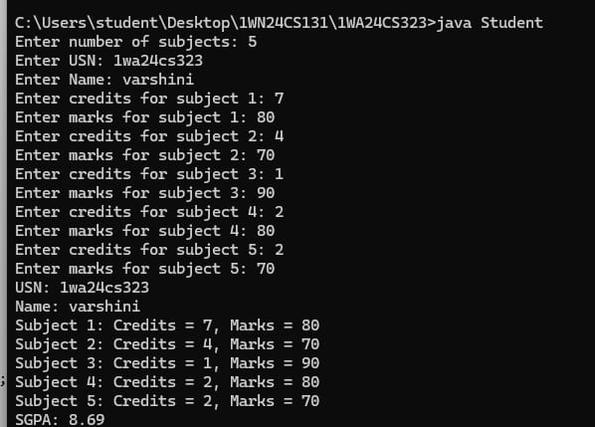

3.Create a class Book which contains four members: name, author, price, num_pages. Include a constructor to set the values for the members. Include methods to set and get the details of the objects. Include a toString( ) method that could display the complete details of the book. Develop a Java program to create n book objects.

import java.util.Scanner;

class Book {
String name;
String author;
double price;
int numPages;

Book(String name, String author, double price, int numPages) {
this.name = name;
this.author = author;
this.price = price;
this.numPages = numPages;
}

void setDetails() {
Scanner scanner = new Scanner(System.in);
System.out.print("Enter book name: ");
this.name = scanner.nextLine();
System.out.print("Enter author name: ");
this.author = scanner.nextLine();
System.out.print("Enter price: ");
this.price = scanner.nextDouble();
System.out.print("Enter number of pages: ");
this.numPages = scanner.nextInt();
scanner.nextLine(); // consume leftover newline
} // ✅ ← Missing this closing brace!

void getDetails() {
System.out.println("Book Name: " + name);
System.out.println("Author: " + author);
System.out.println("Price: Rs " + price);
System.out.println("Number of Pages: " + numPages);
}

public String toString() {
return "Book Details:\n" +
"Name: " + name + "\n" +
"Author: " + author + "\n" +
"Price: Rs " + price + "\n" +
"Number of Pages: " + numPages;
}
}

class Books {
public static void main(String[] args) {
Scanner scanner = new Scanner(System.in);
System.out.print("Enter the number of books: ");
int n = scanner.nextInt();
scanner.nextLine(); // consume newline

Book[] books = new Book[n];

for (int i = 0; i < n; i++) {
System.out.println("\nEnter details for Book " + (i + 1) + ":");
books[i] = new Book("", "", 0.0, 0);
books[i].setDetails();
}

System.out.println("\nDetails of all books:");
for (int i = 0; i < n; i++) {
System.out.println("\nBook " + (i + 1) + ":");
books[i].getDetails();
}

scanner.close();
}
}

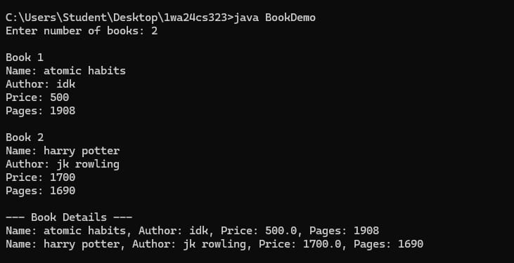

4.Develop a Java program to create an abstract class named Shape that contains two integers and an empty method named printArea(). Provide three classes named Rectangle, Triangle and Circle such that each one of the classes extends the class Shape. Each one of the classes contain only the method printArea() that prints the area of the given shape

abstract class Shape {
int x;
int y;

Shape(int x, int y) {
this.x = x;
this.y = y;
}

abstract void printArea();
}

class Rectangle extends Shape {
Rectangle(int l, int b) {
super(l, b);
}

void printArea() {
System.out.println("Area of Rectangle = " + (x * y));
}
}

class Triangle extends Shape {
Triangle(int b, int h) {
super(b, h);
}

void printArea() {
System.out.println("Area of Triangle = " + (0.5 * x * y));
}
}

class Circle extends Shape {
Circle(int r) {
super(r, 0);
}

void printArea() {
System.out.println("Area of Circle = " + (3.14 * x * x));
}
}

public class ShapeDemo {
public static void main(String[] args) {
Shape r = new Rectangle(10, 5);
Shape t = new Triangle(6, 4);
Shape c = new Circle(7);

r.printArea();
t.printArea();
c.printArea();
}
}
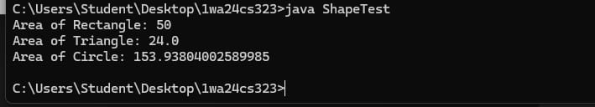

5. Develop a Java program to create a class Bank that maintains two kinds of account for its customers, one called savings account and the other current account. The savings account provides compound interest and withdrawal facilities but no cheque book facility. The current account provides cheque book facility but no interest. Current account holders should also maintain a minimum balance and if the balance falls below this level, a service charge is imposed. Create a class Account that stores customer name, account number and type of account. From this derive the classes Cur-acct and Sav-acct to make them more specific to their requirements. Include the necessary methods in order to achieve the following tasks: a) Accept deposit from customer and update the balance. b) Display the balance. c) Compute and deposit interest d) Permit withdrawal and update the balance Check for the minimum balance, impose penalty if necessary and update the balance.

import java.util.Scanner;
class Account {
protected String customerName;
protected String accountNumber;
protected String accountType;
protected double balance;

public Account(String customerName, String accountNumber, String accountType, double initialBalance) {
this.customerName = customerName;
this.accountNumber = accountNumber;
this.accountType = accountType;
this.balance = initialBalance;
}

public void acceptDeposit(double amount) {
if (amount > 0) {
balance += amount;
System.out.println("Deposited: " + amount);
} else {
System.out.println("Invalid deposit amount.");
}
}
public void showBalance() {
System.out.println("Account Balance: " + balance);
}

public void allowWithdrawal(double amount) {
System.out.println("Withdrawal not implemented for base account.");
}
}

class SavAcct extends Account {
private double interestRate;

public SavAcct(String customerName, String accountNumber, double initialBalance, double interestRate) {
super(customerName, accountNumber, "Savings", initialBalance);
this.interestRate = interestRate;
}

public void applyInterest() {
double interest = balance * interestRate / 100;
balance += interest;
System.out.println("Interest of " + interest + " has been added to your savings account.");
}

public void allowWithdrawal(double amount) {
if (amount > 0 && balance >= amount) {
balance -= amount;
System.out.println("Withdrawn: " + amount);
} else {
System.out.println("Insufficient balance or invalid withdrawal amount.");
}
}
}

class CurAcct extends Account {
private double minimumBalance;
private double serviceCharge;

public CurAcct(String customerName, String accountNumber, double initialBalance, double minimumBalance, double serviceCharge) {
super(customerName, accountNumber, "Current", initialBalance);
this.minimumBalance = minimumBalance;
this.serviceCharge = serviceCharge;
}

public void allowWithdrawal(double amount) {
if (amount <= 0) {
System.out.println("Invalid withdrawal amount.");
return;
}

if (balance - amount >= minimumBalance) {
balance -= amount;
System.out.println("Withdrawn: " + amount);
} else {
balance -= serviceCharge;
System.out.println("Balance fell below minimum. Service charge of " + serviceCharge + " applied.");
}
}

public void showBalance() {
super.showBalance();
if (balance < minimumBalance) {
System.out.println("Warning: Your balance is below the minimum required. Service charges may apply.");
}
}

public void showChequeBookFacility() {
System.out.println("Cheque book facility is available for current account holders.");
}
}

public class bank {
public static void main(String[] args) {
Scanner sc = new Scanner(System.in);

// Savings Account input
System.out.println("Enter details for Savings Account:");
System.out.print("Customer Name: ");
String savName = sc.nextLine();
System.out.print("Account Number: ");
String savAccNo = sc.nextLine();
System.out.print("Initial Balance: ");
double savBalance = sc.nextDouble();
System.out.print("Interest Rate (%): ");
double interestRate = sc.nextDouble();
sc.nextLine();

SavAcct savingsAccount = new SavAcct(savName, savAccNo, savBalance, interestRate);
System.out.println("Savings Account created for " + savName + ".");
savingsAccount.showBalance();

System.out.print("Enter amount to deposit in savings account: ");
double savDeposit = sc.nextDouble();
savingsAccount.acceptDeposit(savDeposit);

savingsAccount.applyInterest();
savingsAccount.showBalance();

System.out.print("Enter amount to withdraw from savings account: ");
double savWithdraw = sc.nextDouble();
savingsAccount.allowWithdrawal(savWithdraw);
savingsAccount.showBalance();

sc.nextLine();
System.out.println("\nEnter details for Current Account:");
System.out.print("Customer Name: ");
String curName = sc.nextLine();
System.out.print("Account Number: ");
String curAccNo = sc.nextLine();
System.out.print("Initial Balance: ");
double curBalance = sc.nextDouble();
System.out.print("Overdraft Limit: ");
double overdraftLimit = sc.nextDouble();
System.out.print("Penalty Fee: ");
double penaltyFee = sc.nextDouble();
sc.nextLine();

CurAcct currentAccount = new CurAcct(curName, curAccNo, curBalance, overdraftLimit, penaltyFee);
System.out.println("Current Account created for " + curName + ".");
currentAccount.showBalance();

System.out.print("Enter amount to deposit in current account: ");
double curDeposit = sc.nextDouble();
currentAccount.acceptDeposit(curDeposit);

System.out.print("Enter amount to withdraw from current account: ");
double curWithdraw = sc.nextDouble();
currentAccount.allowWithdrawal(curWithdraw);
currentAccount.showBalance();

System.out.print("Enter amount to withdraw from current account: ");
double curWithdraw2 = sc.nextDouble();
currentAccount.allowWithdrawal(curWithdraw2);
currentAccount.showBalance();

sc.close();
}
}

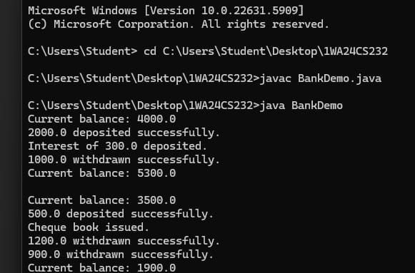

6.Create a package CIE which has two classes - Personal and Internals. The class Personal has members like usn, name, sem. The class Internals has an array that stores the internal marks scored in five courses of the current semester of the student. Create another package SEE which has the class External which is a derived class of Personal. This class has an array that stores the SEE marks scored in five courses of the current semester of the student. Import the two packages in a file that declares the final marks of n students in all five courses.
package CIE;

public class Personal {
public String usn;
public String name;
public int sem;

public Personal(String usn, String name, int sem) {
this.usn = usn;
this.name = name;
this.sem = sem;
}
}

package CIE;

public class Internals {
public int[] marks = new int[5];

public Internals(int[] m) {
for (int i = 0; i < 5; i++) {
marks[i] = m[i];
}
}
}

package SEE;

import CIE.Personal;

public class External extends Personal {
public int[] marks = new int[5];

public External(String usn, String name, int sem, int[] m) {
super(usn, name, sem);
for (int i = 0; i < 5; i++) {
marks[i] = m[i];
}
}
}

import java.util.Scanner;
import CIE.*;
import SEE.*;

public class Main {
public static void main(String[] args) {
Scanner sc = new Scanner(System.in);

System.out.print("Enter number of students: ");
int n = sc.nextInt();

for (int i = 0; i < n; i++) {
System.out.print("USN: ");
String usn = sc.next();

System.out.print("Name: ");
String name = sc.next();

System.out.print("Semester: ");
int sem = sc.nextInt();

int[] im = new int[5];
int[] em = new int[5];

System.out.println("Enter internal marks:");
for (int j = 0; j < 5; j++)
im[j] = sc.nextInt();

System.out.println("Enter SEE marks:");
for (int j = 0; j < 5; j++)
em[j] = sc.nextInt();

Internals in = new Internals(im);
External ex = new External(usn, name, sem, em);

System.out.println("Final Marks:");
for (int j = 0; j < 5; j++) {
System.out.println("Subject " + (j + 1) + ": " + (in.marks[j] + ex.marks[j]));
}
}
sc.close();
}
}

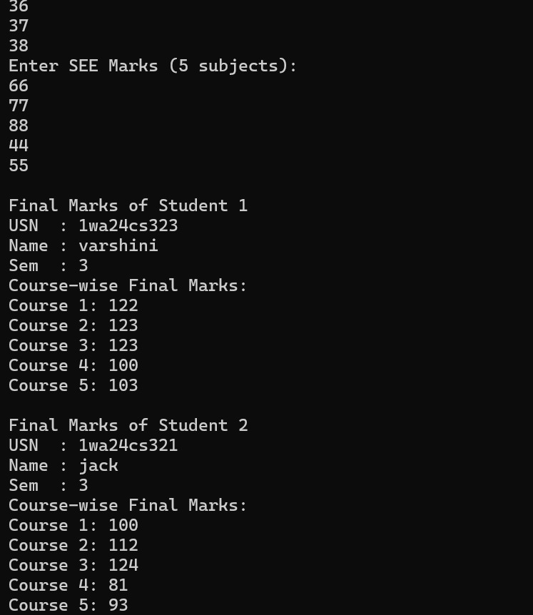
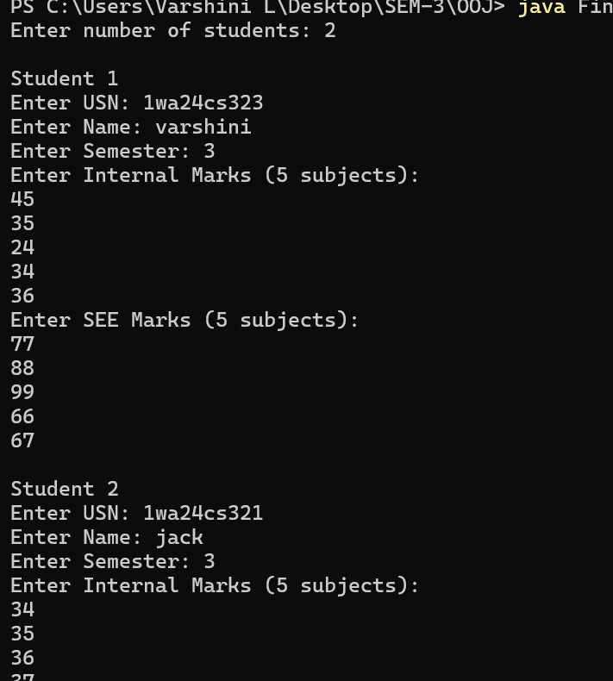

7. Write a program that demonstrates handling of exceptions in inheritance tree. Create a base class called “Father” and derived class called “Son” which extends the base class. In Father class, implement a constructor which takes the age and throws the exception WrongAge( ) when the input age<0. In Son class, implement a constructor that uses both father and son’s age and throws an exception if son’s age is >=father’s age

import java.util.Scanner;
class WrongAge extends Exception {
public WrongAge(String message) {
super(message);
}
}

class Father {
int fatherAge;
public Father(int age) throws WrongAge {
if (age < 0) {
throw new WrongAge("Father's age cannot be negative!");
}
this.fatherAge = age;
}
}

class Son extends Father {
int sonAge;
public Son(int fatherAge, int sonAge) throws WrongAge {
super(fatherAge); // Call Father constructor

if (sonAge < 0) {
throw new WrongAge("Son's age cannot be negative!");
}

if (sonAge >= super.fatherAge) {
throw new WrongAge("Son's age cannot be greater than or equal to Father's age!");
}

this.sonAge = sonAge;
}
}

public class ExceptionInheritanceDemo {
public static void main(String[] args) {
int fage, sage;
Scanner sc=new Scanner(System.in);
System.out.println("Enter father'sage: ");
fage=sc.nextInt();
System.out.println("Enter Son's age: ");
sage=sc.nextInt();
try {
Son s=new Son(fage,sage);
}
catch(WrongAge e){
System.out.println("Exception caught "+e.getMessage());
}
try {
Father s=new Father(fage);
}
catch(WrongAge a){
System.out.println("Exception caught "+a.getMessage());
}
}
}
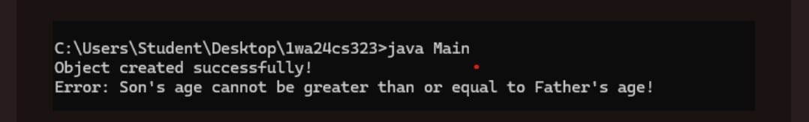
8. Write a program which creates two threads, one thread displaying “BMS College of Engineering” once every ten seconds and another displaying “CSE” once every two seconds.

class Clg extends Thread {
public void run() {
try {
while (true) {
System.out.println("BMS College of Engineering");
Thread.sleep(10000);
}
} catch (InterruptedException e) {
System.out.println("Thread interrupted");
}
}
}

class CSE extends Thread {
public void run() {
try {
while (true) {
System.out.println("CSE");
Thread.sleep(2000);
}
} catch (InterruptedException e) {
System.out.println("Thread interrupted");
}
}
}

public class ThreadDemo {
public static void main(String[] args) {
Clg a = new Clg();
CSE b = new CSE();

a.start();
b.start();
}
}

